**Screenshot of Heading page**



**Screenshot of Search-Box**



**Screenshot of Menu**

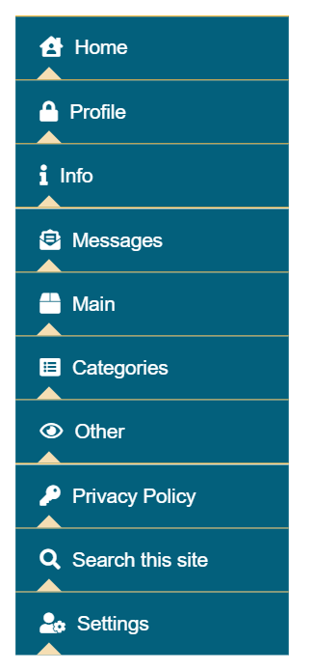

**Screenshot of Login-Box**

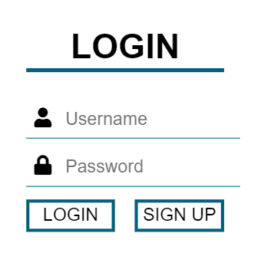

**Screenshot of FAQs**

